**PSG COLLEGE OF TECHNOLOGY, COIMBATORE – 641 004**

**Department of Applied Mathematics and Computational Sciences**

**M Sc SOFTWARE SYSTEMS – Semester IV**

**20XW48 – Web Designing Lab**

**PROBLEM SHEET 2 – Form Tags**

**Start Date: 21.2.2022 Complete Date: 1.3.2022**

* **Swetha Muralidharan**
* **20pw35**

**Forms**

Forms are used to get input from user. This problem sheet is for designing the forms. The exact design specification is also provided. Later the validation could be done using client side scripting code

1. Design a feedback form for a web site. Align the content as below.



|  |
| --- |
| <html>  <head>  <style>  h1  {  color:brown;  text-align:center;  font-size:50px;  font-style : italic ;  font-family: Times new roman;  }  .submit  {  background-color:darkgreen;  color:white;  }  .reset  {  background-color:darkgreen;  color:white;  }    </style>  </head>  <body>  <h1> FEEDBACK </h1>  <p> You can help us to improve our website by using the following form to let us know what you think or what needs <br> to be changed </p>  <center>  <table>  <tr>  <td>  <label> NAME </label>  </td>  <td></td>  <td>  <input label ="text">  <td>  </tr>  <tr>  <td>  <label> EMAIL ADDRESS </label>  </td>  <td></td>  <td>  <input label ="text">  <td>  </tr>  <tr>  <td>  <label> Are you a club member </label>  </td>  <td></td>  <td>  <input type="checkbox">  </td>  </tr>  <tr>  <td>  <label>Your age </label> </td>  <td> </td>  <td> <input type ="radio"> <label> >20 </label>  </td>  </tr>  <tr>  <td colspan="2"> </td>  <td> <input type ="radio"> <label> 21-30 </label> </td> </tr>  <tr>  <td colspan="2"> </td>  <td> <input type="radio"> <label > 31-40 </label> </td>  </tr>  <tr>  <td colspan="2"> </td>  <td> <input type ="radio"> <label> >40 </label> </td>  </tr>  <tr>  <td>  <label> Your state </label>  </td>  <td> </td>  <td>  <select name="state" >  <option> Tamil nadu </option>  <option> Kerala</option>  <option> Andra pradesh </option>  <option> Karnataka </option>  <option> Arunachal pradesh</option>  <option> Goa </option>  <option> Assam </option>  <option> Maharastra </option>  <option> Gujarat </option>  <option> Rajasthan</option>  <option> Sikkim </option>  <option> Madhya Pradesh </option>  <option> West bengal</option>  <option> Meghalaya </option>  <option> Nagaland </option>  <option> Manipur </option>  <option> Bihar </option>  <option> Punjab </option>  <option> Haryana </option>  <option> Telengana </option>  <option> Jharkhand </option>  <option> Odisha </option>  <option> Uttar Pradesh </option>  <option> Uttarakhand</option>  <option> Tripura </option>  <option> Jammu and Kashmir</option>  </select>  </td>  </tr>  <tr>  <td>  <label> How did you <br> find out our site </label>  </td>  <td> </td>  <td><select name="findout" size="3">  <optgroup>  <option> Web search </option>  <option> Link on another site </option>  <option> Told about it </option>  </optgroup>  </select>  </td>  </tr>  <tr>  <td> <label> SITE SUGGESTIONS : </label> </td>  <td> </td>  <td><input type ="text" placeholder="Type your Suggestions here" > </td>  </tr>  <tr>  <td> <label> OTHER COMMENTS : </label> </td>  <td> </td>  <td><input type ="text" placeholder="Additional commands here"></td>  </tr>  <tr>  <td> </td>  <td><input type="submit" class="submit"> </td>  <td><input type="reset" class="reset"> </td>  </table>  </center>  </body> |
|  |

1. Design a customer feedback form for an organization web site. Use tables to make the perfect alignment.

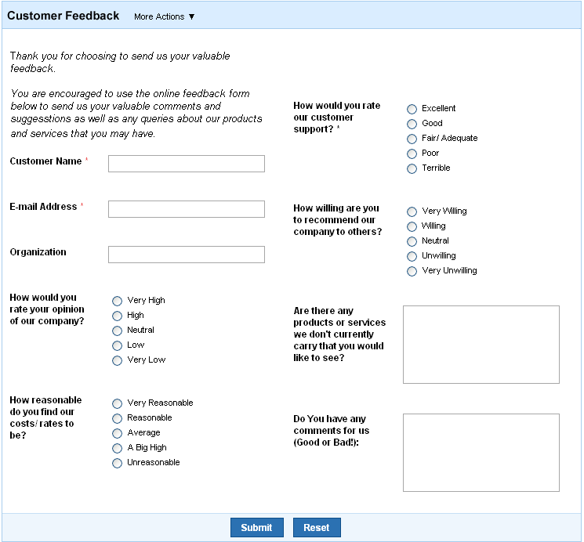

|  |
| --- |
| <html>  <head>  <style>  .title  {  background-color:skyblue;  }  h2  {  font-style:bold;  }  .button  {  background-color:steelblue;  color:white;  }  .end  {  background-color:skyblue;  }    </style>  </head>  <body>  <form>  <table>  <div class="title">  <h2>Customer Feedback</h2>  </div>  <tr>  <td rowspan="1" colspan="2"><p><pre>Thank you for choosing to send us your valuable  feedback.<br>  You are encouraged to use the online feedback form  below to send us your valuable comments and  suggestions as well as any queries about our products  and services that you may have.</pre></p></td>  <td>  <label><b>How would you rate<br>our customer<br>support?\*</b></label>  </td>  <td rowspan="3">  <input type="radio">  <label>Excellent</label><br>  <input type="radio">  <label >Good</label><br>  <input type="radio">  <label >Fair/Accurate</label><br>  <input type="radio">  <label >Poor</label><br>  <input type="radio">  <label>Terrible</label><br>  </td>  </tr>  <tr>  <td><label><b>Customer Name\*</label></td>  <td><input type="text"></td>  </tr>  <td></td>  <td></td>  <td></td>  <td></td>  <tr>  <td><label ><b>Email Adresss\*</label></td>  <td><input type="text"></td>  <td><label ><b>How willing are you<br>to recommand our<br>company to others?</label></td>  <td rowspan="2">  <input type="radio">  <label>Very Willing</label><br>  <input type="radio">  <label>Willing</label><br>  <input type="radio">  <label>Neutral</label><br>  <input type="radio">  <label>Unwilling</label><br>  <input type="radio">  <label> Very Unwilling</label><br>  </td>  </tr>  <tr>  <td rowspan="2"><label><b>Organization</label></td>  <td><input type="text"></td>  </tr>  <td></td>  <td></td>  <td></td>  <td></td>  <tr>  <td><label><b>How would you<br>rate your opinion<br>of our company?</label></td>  <td>  <input type="radio">  <label>Very High</label><br>  <input type="radio">  <label>High</label><br>  <input type="radio">  <label>Neutral</label><br>  <input type="radio">  <label>Low</label><br>  <input type="radio">  <label>Very Low</label><br>  </td>  <td>  <label><b>Are there any<br>products or services<br>we don't currently<br>carry that you would<br>like to see?</b></label>  <td><textarea rows="5" cols="20"></textarea></td>  </td>  </tr>  <td></td>  <td></td>  <td></td>  <td></td>  <tr>  <td ><label ><b>How reasonable<br>do you find our<br>costs/rates to<br>be?</label></td>  <td>  <input type="radio">  <label>Very Reasonable</label><br>  <input type="radio">  <label >Reasonable</label><br>  <input type="radio">  <label>Average</label><br>  <input type="radio">  <label>A Big High</label><br>  <input type="radio">  <label>Unreasonable</label><br>  </td>  <td>  <label><b>Do You have any<br>comments for us<br>(Good or Bad):</b></label>  <td><textarea rows="5" cols="20"></textarea></td>  </td>  </tr>  </table>  <div class="end">  <table>  <tr>  <td><input type="submit" class="button"></td>  <td><input type="reset"class="button" > </td>  </tr>  </table>  </div>  </form>  </body>  </html> |
|  |

1. Design a train ticket reservation form which includes many components.

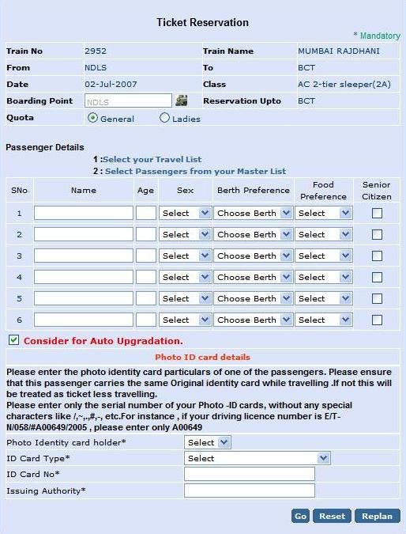

|  |
| --- |
| <html>  <title>Q3</title>  <body bgcolor="lavender">  <center > <h1> Ticket Reservation </h1> </center>  <p align="right"> <font color="green"> \* Mandatory </font> </align> </p>  <form>  <table border="1" bordercolor="white" width="750">  <tr>  <td><b>Train No</b></td>  <td>2952</td>  <td><b>Train Name</b></td>  <td>MUMBAI RAJDHANI</td>  </tr>  <tr>  <td><b>From</b></td>  <td>NDLS</td>  <td><b>To</b></td>  <td>BCT</td>  </tr>  <tr>  <td><b>Date</b></td>  <td>02-July-2007</td>  <td><b>Class</b></td>  <td>AC 2-tier sleeper(2A)</td>  </tr>  <tr>  <td><b>Boarding Point</b></td>  <td></td>  <td><b>Reservation Upto</b></td>  <td>BCT</td>  </tr>  <tr>  <td><b>Quota</b></td>  <td colspan="3"><input type="radio"></input>  <label for="General">General</label>  <input type="radio"></input>  <label for="Ladies">Ladies</label>  </td>  </table>  <p>Passenger Details</p>  <p><pre><font face="Times New Roman">&nbsp&nbsp&nbsp&nbsp&nbsp&nbsp&nbsp&nbsp&nbsp&nbsp&nbsp&nbsp&nbsp&nbsp&nbsp 1 :Select your TravelList  &nbsp&nbsp&nbsp&nbsp&nbsp&nbsp&nbsp&nbsp&nbsp&nbsp&nbsp&nbsp&nbsp&nbsp&nbsp 2 :Select Passangers from your Master ListS</font></pre></p>  <table border="1" bordercolor="white" width="650">  <tr>  <td>SNo</td>  <td>Name</td>  <td>Age</td>  <td>Sex</td>  <td>Birth Preference</td>  <td>Food<br>Preference</td>  <td>Senior<br>Citizen</td>  </tr>  <tr>  <td align="center">1</td>  <td><input type="text" required></input></td>  <td><input type="text" required></input></td>  <td>  <select name="sex" required>  <option> Select </option>  <option> Female</option>  <option> male</option>  </select>  </td>  <td>  <select name="berth" >  <option> Choose berth</option>  <option> Upper</option>  <option> Lower</option>  <option> Middle</option>  </select>  </td>  <td>  <select name="food" >  <option> Food preference</option>  <option> South-Indian</option>  <option> North-Indian</option>  <option> Korean </option>  <option> Chinese</option>  <option> Japanese</option>  <option> Italian</option>  </select>  </td>  <td>  <input type="checkbox"> </input>  </td>  </tr>  <tr>  <td align="center">2</td>  <td><input type="text"></input></td>  <td><input type="text"></input></td>  <td><select name="sex" >  <option> Select </option>  <option> Female</option>  <option> male</option>  </select>  </td>  <td><select name="berth" >  <option> Choose berth</option>  <option> Upper</option>  <option> Lower</option>  <option> Middle</option>  </select>  </td>  <td>  <select name="food" >  <option> Food preference</option>  <option> South-Indian</option>  <option> North-Indian</option>  <option> Korean </option>  <option> Chinese</option>  <option> Japanese</option>  <option> Italian</option>  </select>  </td>  <td> <input type="checkbox"> </input>  </td>  </tr>  <tr>  <td align="center">3</td>  <td><input type="text" required></input></td>  <td><input type="text" required></input></td>  <td>  <select name="sex" required>  <option> Select </option>  <option> Female</option>  <option> male</option>  </select>  </td>  <td>  <select name="berth" >  <option> Choose berth</option>  <option> Upper</option>  <option> Lower</option>  <option> Middle</option>  </select>  </td>  <td>  <select name="food" >  <option> Food preference</option>  <option> South-Indian</option>  <option> North-Indian</option>  <option> Korean </option>  <option> Chinese</option>  <option> Japanese</option>  <option> Italian</option>  </select>  </td>  <td> <input type="checkbox"> </input>  </td>  </tr>  <tr>  <td align="center">4</td>  <td><input type="text" required></input></td>  <td><input type="text" required></input></td>  <td><select name="sex" required>  <option> Select </option>  <option> Female</option>  <option> male</option>  </select>  </td>  <td><select name="berth" >  <option> Choose berth</option>  <option> Upper</option>  <option> Lower</option>  <option> Middle</option>  </select>  </td>  <td><select name="food" >  <option> Food preference</option>  <option> South-Indian</option>  <option> North-Indian</option>  <option> Korean </option>  <option> Chinese</option>  <option> Japanese</option>  <option> Italian</option>  </select>  </td>  <td> <input type="checkbox"> </input>  </td>  </tr>  <tr>  <td align="center">5</td>  <td><input type="text" required></input></td>  <td><input type="text" required></input></td>  <td><select name="sex" required>  <option> Select </option>  <option> Female</option>  <option> male</option>  </select>  </td>  <td><select name="berth" >  <option> Choose berth</option>  <option> Upper</option>  <option> Lower</option>  <option> Middle</option>  </select>  </td>  <td><select name="food" >  <option> Food preference</option>  <option> South-Indian</option>  <option> North-Indian</option>  <option> Korean </option>  <option> Chinese</option>  <option> Japanese</option>  <option> Italian</option>  </select>  </td>  <td> <input type="checkbox" required> </input>  </td>  </tr>  <tr>  <td align="center">6</td>  <td><input type="text" required></input></td>  <td><input type="text" required></input></td>  <td><select name="sex" >  <option> Select </option>  <option> Female</option>  <option> male</option>  </select>  </td>  <td><select name="berth" >  <option> Choose berth</option>  <option> Upper</option>  <option> Lower</option>  <option> Middle</option>  </select>  </td>  <td><select name="food" >  <option> Food preference</option>  <option> South-Indian</option>  <option> North-Indian</option>  <option> Korean </option>  <option> Chinese</option>  <option> Japanese</option>  <option> Italian</option>  </select>  </td>  <td> <input type="checkbox"> </input>  </td>  </tr>  </table>  <input type ="checkbox"> </input> <label> <font color ="red" > <b> Consider for Auto Upgradation </b> </font></label>  <table border=1 bordercolor="white" width="750" border="solid">  <tr rowspan="2" colspan="2">  <td rowspan="1" colspan="2" align="center" > Photo id card details </td>  </tr>  <tr>  <td rowspan="1" colspan="2"><p><b> Please enter the photo identity card particulars of one of the passengers.Please ensure <br>  that this passenger carries the same Original identity card while travelling.If not this will<br>be treated ticket less travelling.<br>  Please enter only the serial number of your Photo -ID cards,without any special<br>characters  like /,`~,.,#,-,etc.For instance,if your driving license number is E/T-<br>  N/058/#A00649/2005,please enter only A00649</b></p></td>  </tr>  <tr>  <td>Photo Identity card holder\*</td>  <td><select name="select">  <option>select</option>  <option>photo</option></td>  </tr>  <tr>  <td>Id Card Type\*</td>  <td><select name="select">  <option>select</option>  <option>adharr</option>  <option>pan card</option></td>  </tr>  <tr>  <td>ID card No\*</td>  <td><input type="text" required></input></td>  </tr>  <tr>  <td>Issuing Authority\*</td>  <td><input type="text" required></input></td>  </tr>  </table>  <td> <button> Go </button> </td>  <td> <input type="reset"></td>  <td> <button> Replan</button></td>  </form>  </body>  </html> |
|  |
|  |

1. Design an event planner which will be helpful in organizing national level competition.

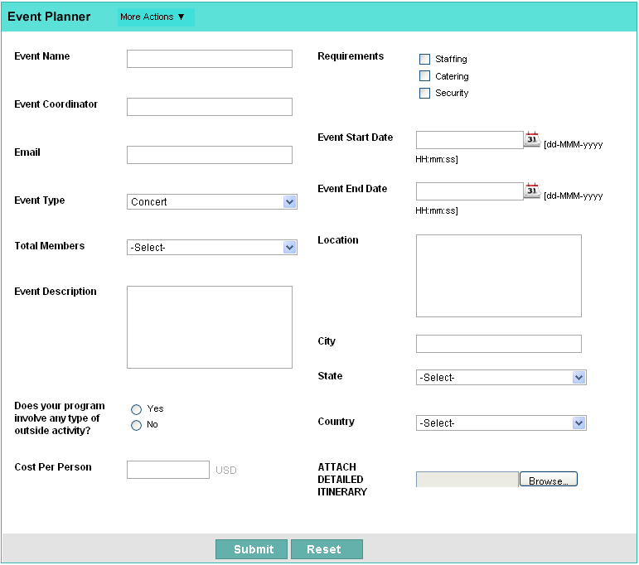

|  |
| --- |
| <html>  <head>  <style>  .event  {  background-color:lightseagreen;  }  .end  {  background-color:lightgrey;  }  .button  {  background-color:lightseagreen;  }  </style>  </head>  <body>  <form>  <div class="event">  <h2> Event planner </h2>  </div>  <table colspan="4">  <tr>  <td>  <label> Event Name </label>  </td>  <td>  <input type="text">  </td>  <td></td>  <td>  <label> Requirements </label>  </td>  <td>  <input type="checkbox">  <label>Staffing </label> <br>  <input type="checkbox">  <label>Cattering </label> <br>  <input type="checkbox">  <label>Security </label>  </td>  </tr>  <tr>  <td>  <label> Event Coordinator </label>  </td>  <td>  <input type="text">  </td>  </tr>  <tr>  <td></td>  <td colspan=2> </td>  <td>  <label> Event start date </label>  </td>  <td>  <input type = "date">  </td>  </tr>  <tr>  <td>  <label> Mail </label>  </td>  <td>  <input type="text">  </td>  </tr>  <tr>  <td></td>  <td colspan="2"> </td>  <td>  <label> Event start date </label>  </td>  <td>  <input type = "date">  </td>  </tr>  <tr>  <td>  <label> Event type </label>  </td>  <td>  <select>  <option> Concert </option>  <option> Concert </option>  <option> Concert </option>  </select>  </td>  </tr>  <tr>  <td></td>  <td colspan="2"> </td>  <td>  <label> Location </label>  </td>  <td>  <textarea rows="5" cols="20"> </textarea>  </td>  </tr>  <tr>  <td>  <label> Total members </label>  </td>  <td>  <select>  <option> -Select- </option>  <option> less than 20 </option>  <option> 20 - 50 </option>  <option> more than 50 </option>  </select>  </td>  </tr>  <tr>  <td>  <label> Event Discription </label>  </td>  <td>  <textarea rows="5" cols="20"> </textarea>  </td>  <td> </td>  <td>  <label> City </label>  </td>  <td>  <input type ="text">  </td>  </tr>  <tr>  <td> </td>  <td colspan="2"> </td>  <td> <label> State </label>  </td>  <td>  <select name="state" >  <option> Select </option>  <option> Tamil nadu </option>  <option> Kerala</option>  <option> Andra pradesh </option>  <option> Karnataka </option>  <option> Arunachal pradesh</option>  <option> Goa </option>  <option> Assam </option>  <option> Maharastra </option>  <option> Gujarat </option>  <option> Rajasthan</option>  <option> Sikkim </option>  <option> Madhya Pradesh </option>  <option> West bengal</option>  <option> Meghalaya </option>  <option> Nagaland </option>  <option> Manipur </option>  <option> Bihar </option>  <option> Punjab </option>  <option> Haryana </option>  <option> Telengana </option>  <option> Jharkhand </option>  <option> Odisha </option>  <option> Uttar Pradesh </option>  <option> Uttarakhand</option>  <option> Tripura </option>  <option> Jammu and Kashmir</option>  </select>  </td>  </tr>  <tr>  <td>  <label> Does your program <br> involve any type of <br>outside activity</label>  </td>  <td>  <input type="radio"> </input>  <label> Yes </label>  <br>  <input type="radio"> </input>  <label> No </label>  </td>  <td> </td>  <td>  <label>Country </label>  </td>  <td>  <select>  <option> Select </option>  <option> India </option>  <option> Oman </option>  <option> Singapore </option>  <option> </option>  </select>  </td>  </tr>  <tr>  <td>  <label> Cost per person </label>  </td>  <td>  <input type="text">  </td>  <td> </td>  <td>  <label> Attached <br> detailed <br> initinery </label>  </td>  <td>  <input type ="file" >  </td>  </tr>  </table>  <div class="end">  <table align="center">  <tr>  <td>  <input type="submit" class="button">  </td>  <td>  <input type="reset"class="button" >  </td>  </tr>  </table>  </div>  </form>  </body> |
|  |

1. Design a form for online accommodation booking system.

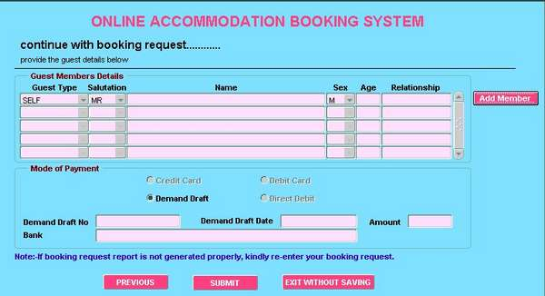

|  |
| --- |
| **<html>**  **<head>**  **<title>Online Accomodation</title>**  **<style>**  **body{**  **font-family: 'Calibri', sans-serif;**  **}**  **h2{**  **color: rgb(250, 66, 97);**  **}**  **tr{**  **text-align: center;**  **}**  **input{**  **background-color: rgb(255, 209, 209);**  **}**  **select{**  **background-color: rgb(255, 209, 209);**  **}**  **button{**  **background-color: rgb(250, 66, 97);**  **color: white;**  **}**  **</style>**  **</head>**  **<body bgcolor="lightblue">**  **<center><h2>ONLINE ACCOMODATION BOOKING SYSTEM</h2></center>**  **<p><font size = 5>continue with booking request.......</font><br>**  **<font size = 2>provide the guest details below</font></p>**  **<hr>**  **<fieldset>**  **<legend><font color="brown"> <b> Guest Member Details</b> </font></legend>**  **<table align="center">**  **<tr>**  **<td colspan="2">Guest Type</td>**  **<td>Salutation</td>**  **<td colspan="3">Name</td>**  **<td>Sex</td>**  **<td>Age</td>**  **<td colspan="2">Relationship</td>**  **</tr>**  **<tr>**  **<td colspan="2"><select>**  **<option>Self</option>**  **<option>Friend</option>**  **</select></td>**  **<td>**  **<select>**  **<option>Mr.</option>**  **<option>Ms.</option>**  **<option>Mrs.</option>**  **</select>**  **</td>**  **<td colspan="3"><input></input></td>**  **<td>**  **<select>**  **<option>M</option>**  **<option>F</option>**  **<option>No gender</option>**  **</select>**  **</td>**  **<td><input></td>**  **<td colspan="2"><input></td>**  **<td colspan="2"><button>Add Member</button></td>**  **</tr>**  **<tr>**  **<td colspan="2"><select>**  **<option>Self</option>**  **<option>Friend</option>**  **</select></td>**  **<td>**  **<select>**  **<option>Mr.</option>**  **<option>Ms.</option>**  **<option>Mrs.</option>**  **</select>**  **</td>**  **<td colspan="3"><input></input></td>**  **<td>**  **<select>**  **<option>M</option>**  **<option>F</option>**  **<option>No gender</option>**  **</select>**  **</td>**  **<td><input></td>**  **<td colspan="2"><input></td>**  **</tr>**  **<tr>**  **<td colspan="2"><select>**  **<option>Self</option>**  **<option>Friend</option>**  **</select></td>**  **<td>**  **<select>**  **<option>Mr.</option>**  **<option>Ms.</option>**  **<option>Mrs.</option>**  **</select>**  **</td>**  **<td colspan="3"><input></input></td>**  **<td>**  **<select>**  **<option>M</option>**  **<option>F</option>**  **<option>No gender</option>**  **</select>**  **</td>**  **<td><input></td>**  **<td colspan="2"><input></td>**  **</tr>**  **<tr>**  **<td colspan="2"><select>**  **<option>Self</option>**  **<option>Friend</option>**  **</select></td>**  **<td>**  **<select>**  **<option>Mr.</option>**  **<option>Ms.</option>**  **<option>Mrs.</option>**  **</select>**  **</td>**  **<td colspan="3"><input></input></td>**  **<td>**  **<select>**  **<option>M</option>**  **<option>F</option>**  **<option>No gender</option>**  **</select>**  **</td>**  **<td><input></td>**  **<td colspan="2"><input></td>**  **</tr>**  **<tr>**  **<td colspan="2"><select>**  **<option>Self</option>**  **<option>Friend</option>**  **</select></td>**  **<td>**  **<select>**  **<option>Mr.</option>**  **<option>Ms.</option>**  **<option>Mrs.</option>**  **</select>**  **</td>**  **<td colspan="3"><input></input></td>**  **<td>**  **<select>**  **<option>M</option>**  **<option>F</option>**  **<option>No gender</option>**  **</select>**  **</td>**  **<td><input></td>**  **<td colspan="2"><input></td>**  **</tr>**  **</table>**  **</fieldset>**  **<fieldset>**  **<legend><font color="Brown"><b>Mode of payment </b> </font> </legend>**  **<table>**  **<tr>**  **<td><input type="radio">Credit Card</td>**  **<td> </td>**  **<td><input type="radio">Debit Card</td>**  **</tr>**  **<tr>**  **<td><input type="radio">Demand Draft</td>**  **<td> </td>**  **<td><input type="radio">Direct Debt</td>**  **</tr>**  **<tr>**  **<td></td>**  **</tr>**  **<tr>**  **<td>Demand Draft No</td>**  **<td><input></td>**  **<td>Demand Draft Date</td>**  **<td><input></td>**  **<td>Amount</td>**  **<td><input></td>**  **</tr>**  **<tr>**  **<td>Bank</td>**  **<td><input type ="text" ></td>**  **</tr>**  **</table>**  **</fieldset>**  **<p style="color: blue;"><b>Note:</b>If booking request is not generated properly,kindly re-enter your booking request.</p>**  **<table align="center">**  **<tr>**  **<td><button> PREVIOUS </button> </td>**  **<td> </td>**  **<td><button> SUBMIT </button> </td>**  **<td> </td>**  **<td><button> EXIT WITHOUT SAVING </button> </td>**  **</tr>**  **</table>**  **</body>**  **</html>** |
|  |

**Note:**

**From questions 6-10 students are requested to create design specification and then do designing the web page.**

1. Design the web form for uploading recipe. Accept images

|  |
| --- |
| <html>  <head>  <style>  .title  {  background-color:skyblue;  text-align:center;  }  h1  {  font-family:arial;  color:white;  }  .end  {  background-color:skyblue;  color:white;  }    </style>  </head>  <body>  <div class="title">  <h1> RECIPE </h1>  </div>  <form>  <table align="center" colspan="4">  <tr>  <td colspan="1"></td>  <td> <label> Recipe No. </label> </td>  <td> <label> Recipe Name : </label> </td>  </tr>  <tr>  <td colspan="1"></td>  <td> <input type="text"> </td>  <td> <input type ="text" > </td>  </tr>  <tr>  <td colspan="3"> </td>  <td> <label> By : </label> <input type ="text"> </td>  </tr>  <tr>  <td> <label> Dish type : </label> </td>  <td> <input type="radio"> <label> Veg </label>  <br>  <input type="radio"> <label> Non-Veg </label>  <br>  <input type="radio"> <label> Beverage </label>  <br>  <input type="radio"> <label> Salads </label>  <br>  <input type="radio"> <label> Desserts </label>  <br>  </td>  </tr>  <tr>  <td> <label> No of servings </label></td>  <td> <input type="text" placeholder="Ex:2- 4 "> </td>  </tr>  <tr>  <td colspan="2"> </td>  <td> <label> Difficulty level :</label></td>  <td> <input type="checkbox"> <label> Easy </label> <br>  <input type="checkbox"> <label> Medium </label> <br>  <input type="checkbox"> <label> Hard </label> </td>  <tr>  <td> <label> Preparation time :</label></td>  <td> <input type="text" placeholder="Ex:20-40 min "> </td>  </tr>  <tr>  <td> <label> Ingrediants Used :</label></td>  <td> <textarea rows="10" cols="20" > </textarea> </td>  <td> <label> Directions :</label></td>  <td> <textarea rows="10" cols="50" > </textarea> </td>  </tr>  <tr>  <td> <label> Upload recipe image </label> </td>  </tr>  <tr>  <td colspan="1"> </td>  <td> <input type ="file" > </td>  </tr>  </table>  <div class="end" >  <table align="center">  <tr>  <td> <input type ="submit"> </td>  <td> <input type="reset"> </td>  </tr>  </table>  </form>  </body>  </html> |
|  |

1. A recruitment agency wants to accept applications online from its applicant. Design web page(s) for the applicant to upload their bio-data.

|  |
| --- |
| <html>  <head>  <style>  h2  {  background-color: orange;  }  .end  {  background-color: orange;  }  button  {  color: white;  background-color:Black;  }  </style>  </head>  <body align="center">  <h2> Bio-Data </h2>  <form>  <table colspan="6">  <tr>  <td> <label> First name \* </label> </td>  <td> <input type="text"> </td>  <td> <label> Middle name </label> </td> <td> <input type="text"> </td>  <td> <label> Last name \* </label> </td> <td> <input type="text"> </td>  </tr>  </table>  <table colspan="4">  <tr>  <td> <label> Date of birth : </label> </td>  <td> <label> mm </label> <textarea rows="1"cols="3"> </textarea>  <label> dd </label> <textarea rows="1" cols="3"> </textarea>  <label> yy </label> <textarea rows="1" cols="3"> </textarea> </td>  <td><label> SSN </label></td> <td><input type="text"> </td>  </tr  <tr  <td> <label> Occupation </label> </td>  <td> <select>  <option> Select </option>  <option> Engineer </option>  <option> Doctor </option>  <option> Architecture </option>  </select> </td>  <td> <label> If other </label></td>  <td> <input type="text"> </td>  </tr>  <tr>  <td> <label> Employer </label></td>  <td> <input type="text"> </td>  <td> <label> Race </label> </td>  <td> <select>  <option> Asian </option>  <option> x </option>  <option> y </option>  <option> z</option>  </select>  </td>  </tr>  <tr>  <td> <label> Primary Language </label></td>  <td> <input type="text"> </td>  <td> <label> Secondary language </label> </td>  <td> <input type="text"> </td>  </tr>  <tr>  <td> <label> Gender\* </label>  <td> <select placeholder="select">  <option> F </option>  <option> M </option>  </select>  </td>  <td> <label> Martial <br> Status </label>  <td> <select placeholder="select">  <option> X </option>  <option> Y </option>  </select>  </td>  </tr>  <tr>  <td> <label> Height <br> (inches) </label></td>  <td> <input type="text"> </td>  <td> <label> Weight <br>(lbs) </label> </td>  <td> <input type="text"> </td>  </tr>  <tr>  <tr>  <td> <label> No.of children </label></td>  <td> <input type="text"> </td>  </tr>  </table>  <div class="end">  <table align="center">  <tr>  <td> <button> Cancel </button>  <button> Next </button>  <button> Done </button> </td>  </tr>  </div>  </table>  </form>  </body>  </html> |
|  |

1. Design student online leave application form. (Refer intranet web site)

|  |
| --- |
| <html>  <head>  <style>  h2  {  color: Red;  text-align:center;  }  </style>  </head>  <body bgcolor="lightblue">  <form>  <table align="center" colspan="4">  <h2> Online Leave Application Form </h2>  <tr>  <td> <label> Student Name: </label> </td>  <td> <input type="text"> </td>  <td> <label> Roll No : </label> </td>  <td> <input type="text"> </td>  </tr>  <tr>  <td> <label> Date of Departure </label> </td>  <td> <input type="date"> </td>  <td> <label> House Address </label> </td>  <td> <textarea rows="3" cols="20" > </textarea></td>  </tr>  <tr>  <td> <label> Date of Return : </label> </td>  <td> <input type="date"> </td>  <td> <label> Total number of <br> school days away:</label> </td>  <td> <input type="text"> </td>  </tr>  <tr>  <td> <label> Reason for leave </label></td>  <td> <input type="checkbox"> <label> Holiday Travel </label><br>  <input type="checkbox"> <label> Family reunion </label><br>  <input type="checkbox"> <label> Funeral </label><br>  </td>  <td> <input type="checkbox"> <label> Wedding </label><br>  <input type="checkbox"> <label> Interstate or National Competiton</label><br>  <input type="checkbox"> <label> other </label><br>  </td>  <tr>  <tr>  <table colspan="2" align="center">  <tr> <td> <label> details </label> </td>  <td> <textarea rows="4" cols="80" > </textarea> </td>  </tr>  </tr>  <tr>  </table>  <table align="center">  <tr>  <td> <input type ="submit"> </td>  <td> <input type="reset"> </td>  </tr>  </table>  </form>  </table>  </body>  </html> |
|  |

1. Design form for user registration process in an online banking.

|  |
| --- |
| <html>  <title>Q7</title>  <body>  <form>  <table colspan="5">  <tr bgcolor="bisque">  <td colspan="4"><font size="5">New User Registration</font.</td>  </tr>  <tr>  <td><font color="red">Mandatory fields are marked withasterisk(\*)</font></td>  </t>  <t>  <td>Account Number<font color="red">\*</font></td>  <td><input type="text"></td>  <td colspan="2">(Account Number is available in your passbook and /orstatement of account)</td>  </r>  <r>  <td>CIF Number<font color="red">\*</font></td>  <td><input type="text"></td>  <td colspan="2">(CIF Number is available in your passbook and/or statement ofaccount)  <tr>  tr>  <td>Branch Code<font color="red">\*</font></td>  <td><input type="text"></td>  <td><button type="button" style="background-color:orange">Get BranchName</button></td>  <td>(Please enter 5 digit branch code)</td>  </tr>  <tr>  <td>Country</td>  <td><select name="country">  <option>--Select Country--</option>  <option>India</option>  <option>USA</option>  <option>UK</option>  <option>Canada</option>  <option>Australia</option>  <option>Africa</option></td>  <td>For Canada,choose USA/CANADA  </tr>  <tr rowspan="2">  <td>Registered Mobile Number<font color="red">\*</font></td>  <td><input type="text"></input>  </tr>  <tr>  <td>Facility Required<font color="red">\*</font></td>  <td><select name="transaction">  <option>--Select Transaction Rights--</option>  <option>abc</option>  <option>def</option>  <option>hij</option>  <option>klm</option>  <option>nop</option>  <option>qrs</option></td>  </tr>  <tr rowspan="2">  <td>Enter the text as shown<font color="red">\*</font></td>  <td>6536D  <input type="text"></input></td>  </tr>  <tr bgcolor="bisque">  <td colspan="5" align="center"><input type="submit"></input>  <input type="reset"></input></td>  </tr>  </form>  </body>  </html> |
|  |

1. Design a form for posting bug report in a peer group.

|  |
| --- |
| <html>  <head>  <style>  h2  {  color: red;  font-family :arial;  }  </style>  <body bgcolor="lightblue">  <h2> Bug report </h2>  <hr>  <table align="center" colspan="2">  <form>  <tr>  <td> <label> Bug title </label> </td>  <td> <input type="text"> </td>  </tr>  <tr>  <td> <label> Issue Discription </label> </td>  <td> <textarea rows="4" cols="80" > </textarea> </td>  </tr>  <tr>  <td> <label> Operating System </label> </td>  <td> <select>  <option> Windows XP </option>  <option> Mac </option> </td>  </tr>  <tr>  <td> <label> Priority </label> </td>  <td> <input type="radio"> <label> Low </label> <br>  <input type="radio"> <label> Medium </label> <br>  <input type="radio"> <label> High </label>  </td>  </tr>  <tr>  <td> <label> Screen shot </label> </td>  <td> <input type="file"> </td>  <tr>  <tr>  <td> <input type="submit"> </td>  </tr>  </table>  </form>  </body>  </html> |
|  |

**Note: Students can have a look at the following pages [6-16] for sample web design using HTML form element.**

**Sample HTML Form Designs**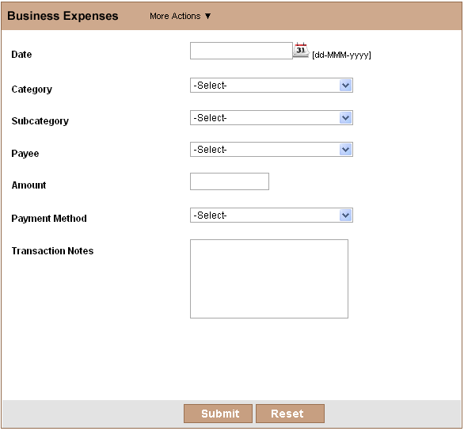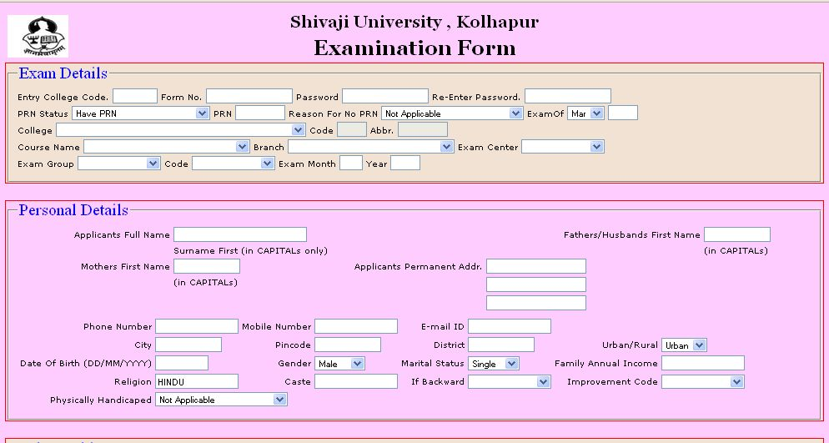

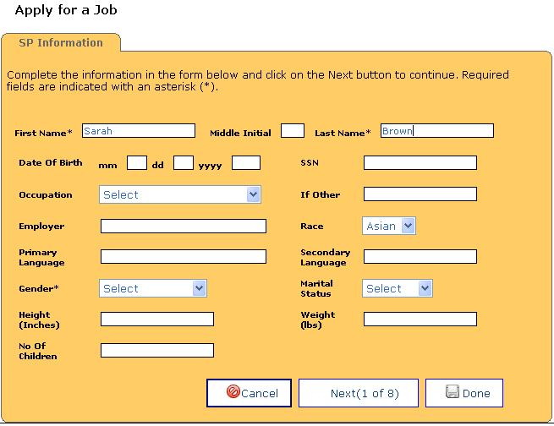

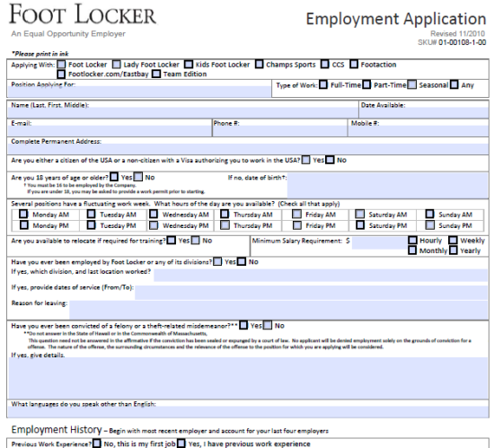

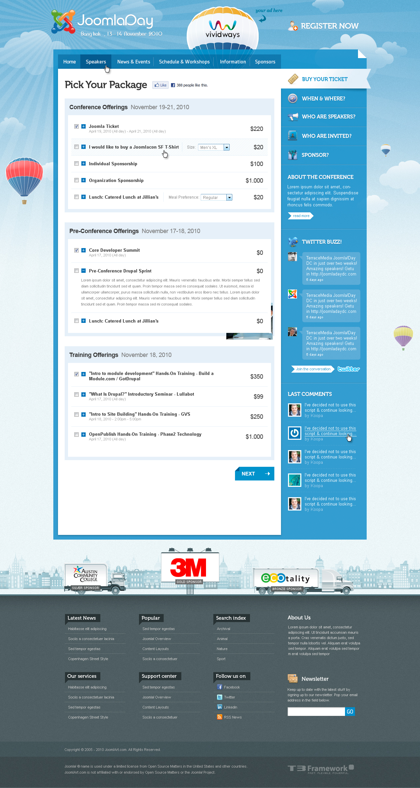

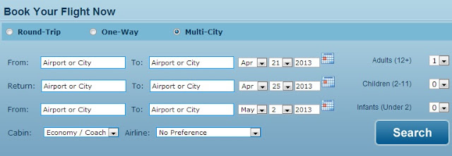

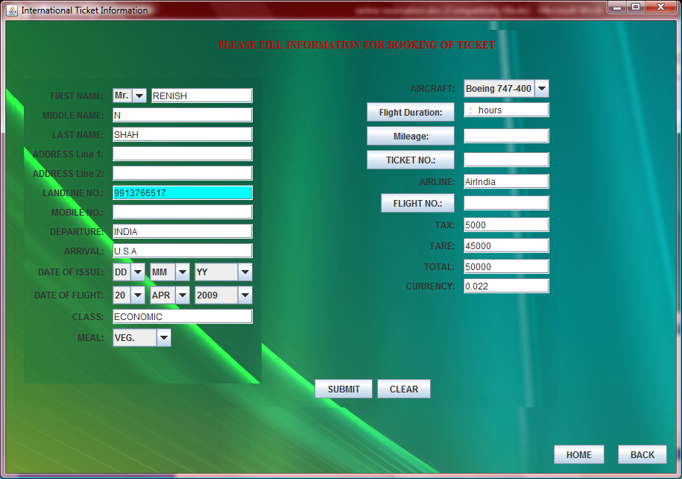

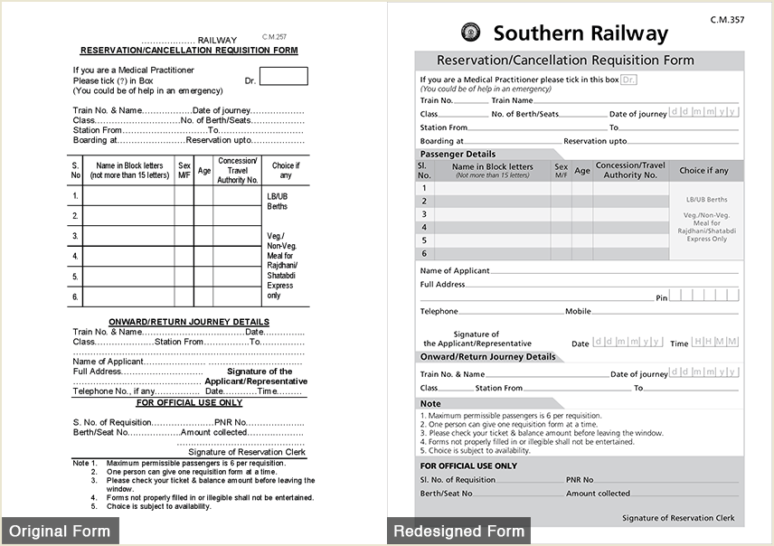

1. Create an order form as shown below.

|  |  |
| --- | --- |
|  | |
|  | |
|  |  |
|  |  |
|  | |
|  | |

|  |
| --- |
|  |
| http://www.zoho.com/creator/images/subpages/htmlforms/time_sheet.gif  http://www.zoho.com/creator/images/subpages/htmlforms/cancellation_survey.gif  http://www.zoho.com/creator/help/images/field-note.png  C:\Documents and Settings\Anandhi\Desktop\contact_manager.gif |